Unit 4 – Lesson 2. Mobile App Design: From Idea to Development
Aim:
- What is SQL and what are some of the most commonly used SQL commands?
- How do we write a simple SQL query to construct a table, query a table and display the result?

Objectives: After the lesson, students will be able to:
- Obtain basic understanding of SQL query and SQL command
- Use Oracle Live SQL to create simple SQL scripts

CLASS PROCEDURE:

Do Now: How do we write a product and technical requirements document for an Android App?
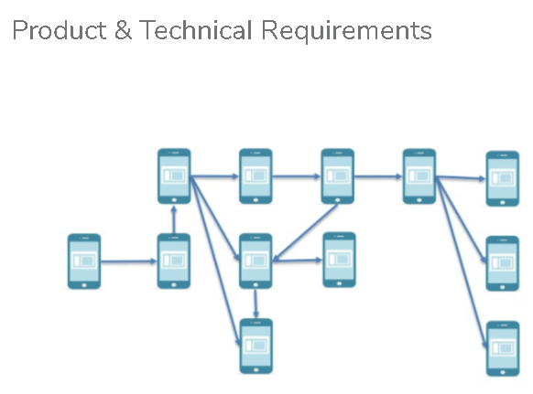

Class Discussion / Presentation:
- If we have an idea for a mobile app, how do we design the app product based upon that initial idea?
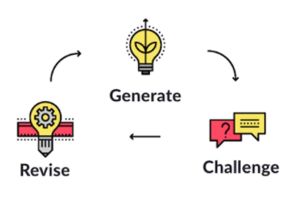
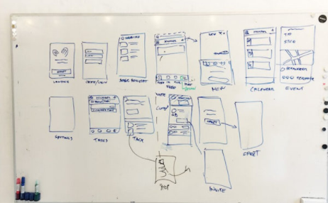

- What shall we include in a design document?
- UI flowchart
- Layout and UI components of each UI
- User expectations (on which UI, user action / input / tab / touch events, expected results etc.)
- Functional specification & description of technical design

Pair – sharing Activity: Read the article online
https://www.smashingmagazine.com/2017/05/writing-mobile-application-requirements

Work with your partner on a design document for your SMS App project. Share the google doc with me today.

Your document must include the following components:

- General description of the idea and purpose of the app
- A hand draw UI flowchart with the name of each UI
- For each UI, draw the layout and UI components (buttons, texts, etc.)
- For each UI component, describe the user action (click, input, tab, etc) and expected user experience (output, new button, new screen, etc)
- For the events, describe the technical design plan (activity, key components, classes, methods,etc.)

